How To Set Up Master Slave Replication on PostgreSQL on an Ubuntu 12.04 VPS
PostedOctober 29, 2013 310k views PostgreSQL Load Balancing Backups Ubuntu

Status: Deprecated
This article covers a version of Ubuntu that is no longer supported. If you are currently operate a server running Ubuntu 12.04, we highly recommend upgrading or migrating to a supported version of Ubuntu:
- Upgrade to Ubuntu 14.04.
- Upgrade from Ubuntu 14.04 to Ubuntu 16.04
- Migrate the server data to a supported version
Reason: Ubuntu 12.04 reached end of life (EOL) on April 28, 2017 and no longer receives security patches or updates. This guide is no longer maintained.
See Instead:
This guide might still be useful as a reference, but may not work on other Ubuntu releases. If available, we strongly recommend using a guide written for the version of Ubuntu you are using. You can use the search functionality at the top of the page to find a more recent version.

Introduction
PostreSQL, or postgres, is a popular database management system that can organize and manage the data associated with websites or applications. Replication is a means of copying database information to a second system in order to create high availability and redundancy.
There are many ways to set up replication on a postgres system. In this tutorial, we will cover how to configure replication using a hot standby, which has the advantage of being relatively simple to configure.
To do this, we will need two Ubuntu 12.04 VPS instances. One will serve as the master database server and the other will function as a slave, which will replicate.

Install PostgreSQL Software
The steps in this section should be performed on both the master and slave servers.
The postgres software is available in Ubuntu's default repositories. Install the appropriate packages with these commands.
sudo apt-get update
sudo apt-get install postgresql postgresql-contrib postgresql-client
PostgreSQL creates a user called "postgres" in order to handle its initial databases. We will configure ssh access between our servers to make transferring files easier.
We will need to set a password for the postgres user so that we can transfer the key files initially. If you desire, you can remove the password at a later time:
sudo passwd postgres
Switch over to the postgres user like this:
sudo su - postgres
Generate an ssh key for the postgres user:
ssh-keygen
Press "ENTER" to all of the prompts that follow.
Transfer the keys to the other server by typing:
ssh-copy-id IP_address_of_opposite_server
You should now be able to ssh freely between your two servers as the postgres user.

Configure the Master Server
We will begin by configuring our master server. All of these commands should be executed with the postgres user.
First, we will create a user called "rep" that can be used solely for replication:
psql -c "CREATE USER rep REPLICATION LOGIN CONNECTION LIMIT 1 ENCRYPTED PASSWORD 'yourpassword';"
Change the password to whatever you'd like to use.
Next, we will move to the postgres configuration directory:
cd /etc/postgresql/9.1/main
We will modify the access file with the user we just created:
nano pg_hba.conf
At any place not at the bottom of the file, add a line to let the new user get access to this server:
host replication rep IP_address_of_slave/32 md5
Save and close the file.
Next, we will open the main postgres configuration file:
nano postgresql.conf
Find these parameters. Uncomment them if they are commented, and modify the values according to what we have listed below:
listen_addresses = 'localhost,IP_address_of_THIS_host'
wal_level = 'hot_standby'
archive_mode = on
archive_command = 'cd .'
max_wal_senders = 1
hot_standby = on
Save and close the file.
Restart the master server to implement your changes:
service postgresql restart

Configure the Slave Server
Begin on the slave server by shutting down the postgres database software:
service postgresql stop
We will be making some similar configuration changes to postgres files, so change to the configuration directory:
cd /etc/postgresql/9.1/main
Adjust the access file to allow the other server to connect to this. This is in case we need to turn the slave into the master later on down the road.
nano pg_hba.conf
Again, add this line somewhere not at the end of the file:
host replication rep IP_address_of_master/32 md5
Save and close the file.
Next, open the postgres configuration file:
nano postgresql.conf
You can use the same configuration options you set for the master server, modifying only the IP address to reflect the slave server's address:
listen_addresses = 'localhost,IP_address_of_THIS_host'
wal_level = 'hot_standby'
archive_mode = on
archive_command = 'cd .'
max_wal_senders = 1
hot_standby = on
Save and close the file.

Replicating the Initial database:
Before the slave can replicate the master, we need to give it the initial database to build off of. This is because it reads the logs off of the master server and applies the changes to its own database. We need that database to match the master database.
On the master server, we can use an internal postgres backup start command to create a backup label command. We then will transfer the database data to our slave and then issue an internal backup stop command to clean up:
psql -c "select pg_start_backup('initial_backup');"
rsync -cva --inplace --exclude=*pg_xlog* /var/lib/postgresql/9.1/main/ slave_IP_address:/var/lib/postgresql/9.1/main/
psql -c "select pg_stop_backup();"
The rsync command may have had an error on modifying the certificate files, but this is okay for our use. The master's data should now be on the slave.
We now have to configure a recovery file on our slave. On the slave navigate to the data directory:
cd /var/lib/postgresql/9.1/main
Here, we need to create a recovery file called recovery.conf:
nano recovery.conf
Fill in the following information. Make sure to change the IP address of your master server and the password for the rep user you created:
standby_mode = 'on'
primary_conninfo = 'host=master_IP_address port=5432 user=rep password=yourpassword'
trigger_file = '/tmp/postgresql.trigger.5432'
The last line in the file, trigger_file, is one of the most interesting parts of the entire configuration. If you create a file at that location on your slave machine, your slave will reconfigure itself to act as a master.
This will break your current replication, especially if the master server is still running, but is what you would need to do if your master server goes down. This will allow the slave to begin accepting writes. You can then fix the master server and turn that into the slave.
You should now have the pieces in place to start your slave server. Type:
service postgresql start
You'll want to check the logs to see if there are any problems. They are located on both machines here:
less /var/log/postgresql/postgresql-9.1-main.log
You should see that it is successfully connecting to the master server.

Test the Replication
We will see first-hand if our servers are replicating correctly by making some changes on the master server and then querying the slave.
On the master server, as the postgres user, log into the postgres system by typing:
psql
Your prompt will change to indicate that you are now communicating with the database software.
We will create a test table to create some changes:
CREATE TABLE rep_test (test varchar(40));
Now, we can insert some values into the table with the following commands:
INSERT INTO rep_test VALUES ('data one');
INSERT INTO rep_test VALUES ('some more words');
INSERT INTO rep_test VALUES ('lalala');
INSERT INTO rep_test VALUES ('hello there');
INSERT INTO rep_test VALUES ('blahblah');
You can now exit out of this interface by typing:
\q
Now, on the slave, enter the database interface in the same way:
psql
Now, we can see if the data we entered in the master database has been replicated on the slave:
SELECT * FROM rep_test;
test
-----------------
data one
some more words
lalala
hello there
blahblah
(5 rows)
Excellent! Our data has been written to both the master and slave servers.
Let's see if we can insert more data into the table on our slave:
INSERT INTO rep_test VALUES ('oops');
ERROR: cannot execute INSERT in a read-only transaction
As you can see, we are unable to insert data into the slave. This is because the data is only being transferred in one direction. In order to keep the databases consistent, postgres must make the slave read-only.

Conclusion
You should now have a master and slave PostgreSQL server configured to communicate effectively. If you have an application that will be writing to and querying the databases, you could set up a load balancing scheme to always write to the master, but split the reads between the master and slave. This could increase the performance of your database interactions.
By Justin Ellingwood

How to Install and Configure PostgreSQL Replication with Hot Standby on Ubuntu 15.04
PostgreSQL or Postgres is an open source object-relational database management system (ORDBMS) with more than 15 years of active development. It's a powerful database server and can handle high workloads. PostgreSQL can be used on Linux, Unix, BSD and Windows servers.
The master/slave database replication is a process of copying (syncing) data from a database on one server (the master) to a database on another server (the slaves). The main benefit of this process is to distribute databases to multiple machines, so when the master server has a problem, there is a backup machine with same data available for handling requests without interruption.
PostgreSQL provides several ways to replicate a database. It can be used for backup purposes and to provide a high availability database server. In this tutorial, we I will show you how to install and configure PostgreSQL replication by using hot standby mode. Hot standby mode is easy to configure, and it's a very good starting point to learn PostgreSQL in depth.
Hot standby mode requires 2 database servers, we will use Ubuntu as operating system on both servers.
- Master Server - accepts connections from the client with read and write permissions.
- Slave Server - the standby server runs copy of the data from the master server with read-only permission.
Prerequisites
- 2 Ubuntu servers - 1 for master and 1 for slave.
- Root privileges on the servers.
- Some basic knowledge about Ubuntu, apt, etc.

Step 1 - Setup the Hostname
Login to both servers with ssh:
ssh user@masterip
ssh user@slaveip
Now set the hostname for both servers - master server and slave server - with the hostnamectl command.
On the master server:
sudo hostnamectl set-hostname master-server
On the slave server:
sudo hostnamectl set-hostname slave-server
Next, edit the /etc/hosts file with vim editor:
sudo vim /etc/hosts
Paste this configuration for the master server:
192.168.1.249 master-server
Paste this configuration for the slave server:
192.168.1.248 slave-server
Save the file and exit the editor.

Step 2 - Install PostgreSQL on Master and Slave Server
Before we start to install PostgreSQL, update the Ubuntu repository:
sudo apt-get update
Next, install PostgreSQL with all its dependencies:
sudo apt-get install postgresql postgresql-client postgresql-contrib
After Postgres installed, give a new password for postgres user (created automatically when the installation).
passwd postgres
Type your postgres user password.
Now testing the PostgreSQL:
su - postgres
psql
\conninfo
You will see result below:
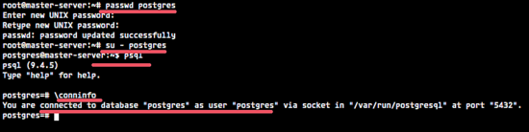

Step 3 - Configure Master-server
In this step, we will configure the 'master server' with IP address '192.168.1.249'. We will create a new user/role with special permission to perform the replication, then we edit the PostgreSQL configuration file to enable the hot standby replication mode.
From the root privileges, switch to the PostgreSQL user with the su command:
su - postgres
Access the Postgres shell with the psql command and type in this PostgreSQL query to create the new user/role:
psql
CREATE USER replica REPLICATION LOGIN ENCRYPTED PASSWORD 'replicauser@';
Check new replica user with PostgreSQL command below:
\du
New replica user has been created.
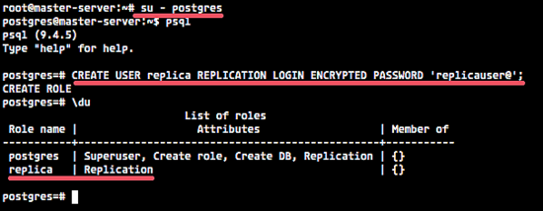
Next, go to the PostgreSQL directory '/etc/postgresql/9.4/main' to edit the configuration file.
cd /etc/postgresql/9.4/main/
Open the postgresql.conf file with vim:
vim postgresql.conf
Uncomment line 59 and add the server IP address.
listen_addresses = 'localhost,192.168.1.249'
In the WAL (Write Ahead Log) setting line 175, uncomment and change the value to hot_standby.
wal_level = hot_standby
In the checkpoints section line 199, uncomment the 'checkpoint_segments' and change the value to 8.
checkpoint_segments = 8
In the archive section line 206 and 208, turn on the archiving option and add the archiving command.
archive_mode = on
archive_command = 'cp -i %p /var/lib/postgresql/9.4/main/archive/%f'
In the replication section line 224 and 226, change the value to the max number of WAL sender process.
max_wal_senders = 3
wal_keep_segments = 8
Save the file and exit vim.
Now create a new directory inside of the 'main' directory for the archive configuration - run the command below as postgres user:
mkdir -p /var/lib/9.4/main/archive/
Next, edit pg_hba.conf file to allow the replication connection.
vim pg_hba.conf
In the end of the line, add a new configuration for user 'replica' to make the connection.
host replication replica 192.168.1.248/24 md5
#192.168.1.248 is slave-server ip address
Save and exit.

Step 4 - Slave-server Configuration
Configure the slave server like the master server. Use su to become the postgres user and go to the PostgreSQL configuration directory.
su - postgres
cd /etc/postgresql/9.4/main/
Edit the postgresql.conf with vim:
vim postgresql.conf
Uncomment line 59 and add the slave server IP address.
listen_addresses = 'localhost,192.168.1.248'
Go to line 175 and uncomment the wal_level setting, change the value to hot_standby.
wal_level = hot_standby
Uncomment line 199 on the checkpoint section.
checkpoint_segments = 8
Uncomment line 224 and 226 to configure max_wal_sender process.
max_wal_senders = 3
wal_keep_segments = 8

Uncomment line 245 to enable hot_standby mode on the slave server.
hot_standby = on
Save and exit.

Step 5 - Syncronize Data from Master server to Slave server
In this step, we will move the PostgreSQL data directory '/var/lib/postgresql/9.4/main' to a backup folder and then replace it with the latest master data with 'pg_basebackup' command.
Run all the command sbelow on the slave server only!
Stop PostgreSQL on the slave server:
systemctl stop postgresql
Now login to the postgres user and rename the 'main' directory to 'main_original' as a backup.
su - postgres
mv 9.4/main 9.4/main_original
Run the command below to copy data from the master server to slave server:
pg_basebackup -h 192.168.1.249 -D /var/lib/postgresql/9.4/main -U replica -v -P
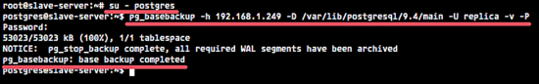
Note:
- 192.168.1.249 is master server IP address.
- And you will be prompted to entering the password for user 'replica' for the replication.
Go to the new 'main' directory and create the new recovery file 'recovery.conf' with vim:
cd /var/lib/postgresql/9.4/main/
vim recovery.conf
Paste the configuration below:
standby_mode = 'on'
primary_conninfo = 'host=192.168.1.249 port=5432 user=replica password=replicauser@'
restore_command = 'cp //var/lib/postgresql/9.4/main/archive/%f %p'
trigger_file = '/tmp/postgresql.trigger.5432'
Now back to the root user with exit and start PostgreSQL with systemctl command:
exit
systemctl start postgresql
Make sure there is no error after run the start command.

Step 6 - Testing
Go to the master server and log into the postgres user, then run the command below to see the replication info.
su - postgres
psql -x -c "select * from pg_stat_replication;"
You will see the replication info below:
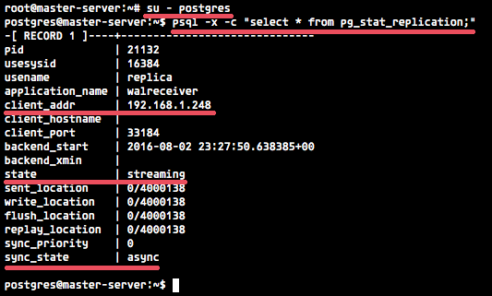
Next, test to create a new database from the master server and then check that the database exist on the slave server.
su - postgres
psql
create database howtoforge;
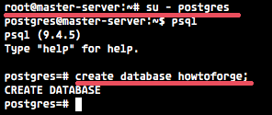
Now login to the slave server and check that the 'howtoforge' database has been mirrored to the slave server automatically.
su - postgres
psql
\list
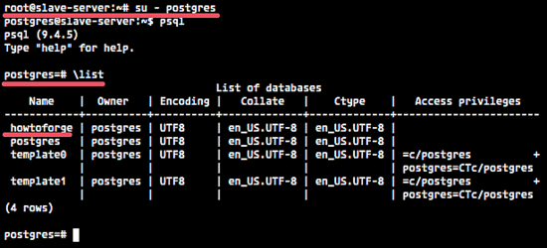
The database has been replicated from the master server to the slave server.

Reference
- http://pgpen.blogspot.com/2013/07/recoverability-of-postgresql-2-setup-of.html
- https://cloud.google.com/solutions/setup-postgres-hot-standby

Greg Reinacker's Weblog

Musings on just about everything.
Skip to content
- Home
- About Me

Zero to PostgreSQL streaming replication in 10 mins
I’ve found a number of articles on the web for setting up streaming replication in PostgreSQL, but none of them seemed to actually put everything together that I needed, and none of them seemed to use the new pg_basebackup in PostgreSQL 9.1 and later. So with that in mind, here are a set of steps you can use to set up streaming replication, over the internet if you wish, using an encrypted SSL connection. We’re not going to set up log archiving – we’re going to rely solely on the streaming replication for now.
I’m assuming you have a master server set up on Ubuntu 10.04 or 12.04, running PostgreSQL 9.2.x, and you have a new slave server set up on the same OS and pg version. The IP of the master is 1.2.3.4, and the IP of the slave is 5.6.7.8.
First, create the replication user on the master:

sudo -u postgres psql -c "CREATE USER replicator REPLICATION LOGIN ENCRYPTED PASSWORD 'thepassword';"

Note that we are using REPLICATION permissions, rather than creating a superuser.
Next, configure the master for streaming replication. Edit postgresql.conf (on Ubuntu, this is at /etc/postgresql/9.2/main/postgresql.conf):

listen_address = # make sure we're listening as appropriate
wal_level = hot_standby
max_wal_senders = 3
checkpoint_segments = 8

wal_keep_segments = 8

We’re configuring 8 WAL segments here; each is 16MB. If you expect your database to have more than 128MB of changes in the time it will take to make a copy of it across the network to your slave, or in the time you expect your slave to be down for maintenance or something, then consider increasing those values.
Then edit the access control on the master to allow the connection from the slave; in pg_hba.conf (/etc/postgresql/9.2/main/pg_hba.conf on Ubuntu):

hostssl replication replicator 5.6.7.8 md5

In this case, 5.6.7.8 is the IP address of the slave that will be connecting for replication, and hostssl means this host can only connect via SSL.
You’ll need to restart the master after making the above changes.
Now on to the slave. In the slave’s postgresql.conf, add the following:

wal_level = hot_standby
max_wal_senders = 3
checkpoint_segments = 8
wal_keep_segments = 8

hot_standby = on

Then restart the slave. No changes are required in the slave’s pg_hba.conf specifically to support replication. You’ll still need to make whatever entries you need in order to connect to it from your application and run queries, if you wish.
That’s all the initial setup we need to do. After you’ve done the above configuration, running the following script on the slave will copy the database over and begin replication (1.2.3.4 is the IP of the master):

echo Stopping PostgreSQL
sudo service postgresql stop
echo Cleaning up old cluster directory
sudo -u postgres rm -rf /var/lib/postgresql/9.2/main
echo Starting base backup as replicator
sudo -u postgres pg_basebackup -h 1.2.3.4 -D /var/lib/postgresql/9.2/main -U replicator -v -P
echo Writing recovery.conf file
sudo -u postgres bash -c "cat > /var/lib/postgresql/9.2/main/recovery.conf <<- _EOF1_
standby_mode = 'on'
primary_conninfo = 'host=1.2.3.4 port=5432 user=replicator password=thepassword sslmode=require'
trigger_file = '/tmp/postgresql.trigger'
_EOF1_
"
echo Startging PostgreSQL

sudo service postgresql start

That script will stop the slave, delete the old slave cluster directory, run pg_basebackup connecting to the master to copy over the databases (you’ll see the progress as it goes), create a new recovery.conf file, and start the slave. If you look at the logs after this script completes, you should hopefully see messages about it having reached a consistent recovery state.
Be careful – that script is going to delete the old database cluster on your slave, so make sure to read through it and understand what it’s doing.
At this point, you can try writing data to the master database, and you should see it mirrored over to the slave. To check the replication status, you can run the following on the master:

sudo -u postgres psql -x -c "select * from pg_stat_replication;"

If you found this guide handy, you might also find the PostgreSQL 9 High Availability Cookbook useful as well!

Database Replication with PostgreSQL 9
Replication is a basic technology for any database server because the downtime or the data loss can result in reducing accessibility, productivity and product confidence. Using data replication from a master server to one or more standbys decreases the possibility of any data loss. With PostgreSQL, you can easily create a database cluster with one or more standby servers, which are ready to inherit and perform operations in case the master server fails.
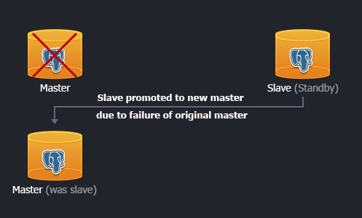

Using WAL (Write-Ahead Logging) data is the fastest available way of replication with a great performance, so-called asynchronous replication. In this case the master database server works in archiving mode just writing the data to the storage. While the standby database cluster operates in recovery mode, reading the master's WAL files. These files are transferred to the standby DB promptly after writing is completed. In such a way, if master server totally fails, the WAL content streams to the standby cluster with just a few seconds delay.
So, let's see how to get advantages of PostgreSQL database clustering and high availability by setting up the hot standby (or streaming) replication, i.e. asynchronous binary replication to one or more standbys, queried as a read-only databases.
You are able to set a DB cluster in a two ways:
- automatically (via one-click widget)
- manually (following the step-by-step instruction)

One-click Installation
You can get a PostgreSQL cluster with two databases up and running within minutes using Jelastic one-click install option.

The process is simple.
Just click Get it hosted now and type your email. You’ll get an environment with replicated master and slave databases just in a minute, skipping the steps of manual installation.
Note that current widget is provided for beta testing of automated Master-Slave DB replication adjustment. Therefore you should take into consideration a few peculiarities it has:
- after the environment creation you’ll receive just one email with admin credentials to your master database
- slave DB can be accessed only via SSH protocol using master database credentials
The complete and full-featured one-click solution will be provided in the nearest future.

Manual Installation
If you prefer to configure the Master-Slave replication manually in order to get more slave replicators or specify some custom configurations, please, follow the instruction below.

Create Environments
At the very beginning let's create two identical environments with PostgreSQL nodes: the first one for master DB and the second one for the standby.
- Log into the Jelastic dashboard.
- Click the Create environment button in the top left corner of the dashboard. Then in the topology wizard select PostgreSQL 9 as the database you want to use and set the cloudlet limits for it. Enter the name for the environment with your master database and click Create.
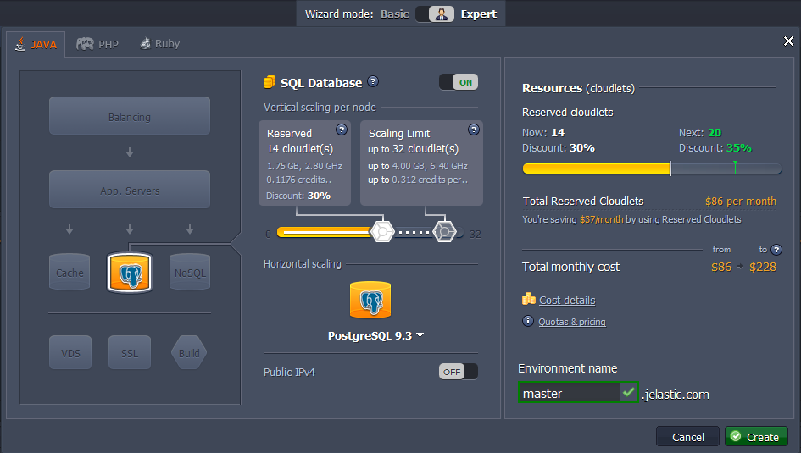
It will take just a minute to create the environment. After that you'll see a new environment with PostgreSQL database in the Jelastic dashboard.

- Create another environment with the PostgreSQL database in the same way as it is described above or you can just clone already existing one.
In case of using cloning for the second environment creation, credentials for admin access to the second DB will be the same as for the first one.
PostgreSQL in the second environment will be your standby database, located on another hardware node. It is much more secure and reliable for storing your data.
For now you have two identical environments with PostgreSQL database node in each one.
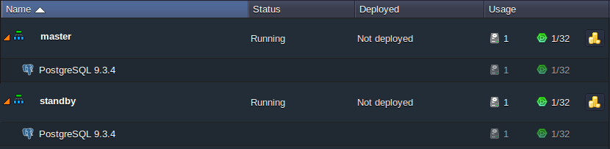

Configuring Master PostgreSQL
- Find the environment with the master database in your environment list. Click the Config button next to the PostgreSQL node.
- Open the conf directory and navigate to the postgresql.conf file. Find the following lines in the file, uncomment them, and specify the next settings’ values for enabling streaming replication:
wal_level = hot_standby
max_wal_senders = 3
archive_mode = on
archive_command = 'cp %p /tmp/%f'
Value in the max_wal_senders string depends on the amount of standby servers you are going to use. Stating 3 means you can configure the replication of your master DB server to three standby DB servers.
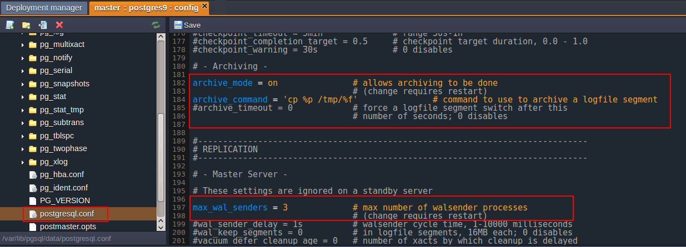
Press the Save button above the editor.
- Open the pg_hba.conf configuration file, which is located in the same conf folder. Permit the standby database cluster connection by stating the following parameters:
host replication all {standby_IP_address}/32 trust
In order to get the IP address of any server, click the Info button next to it and copy the address in the opened frame:
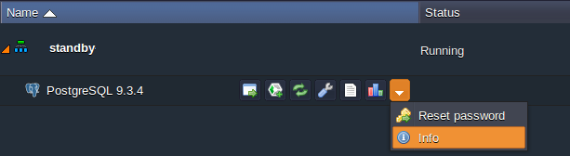
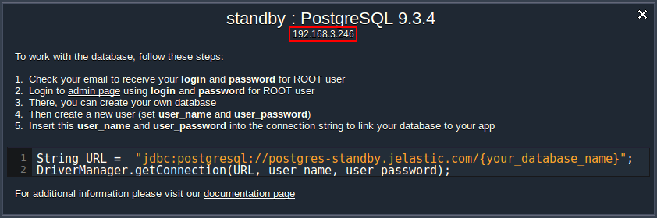
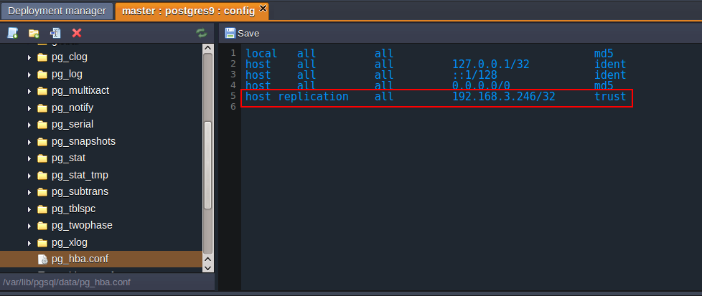
Don’t forget to Save the changes you’ve performed.
- Now you should access your environment with master DB via SSH and enter the PostgreSQL container it contains.

In the case you haven’t done the similar operations before, you need to:
- generate an SSH keypair
- add your public SSH key to the dashboard
- access your account via SSH protocol
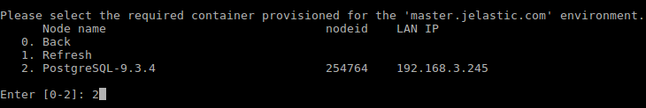
- Once you’ve entered the container, stop it with the following command:
sudo service postgresql stop
- Then execute the next line in order to delete the old WAL log file and simultaneously create a new empty one:
/usr/pgsql-9.3/bin/pg_resetxlog -f /var/lib/pgsql/data/
- Finally, start the container:
sudo service postgresql start
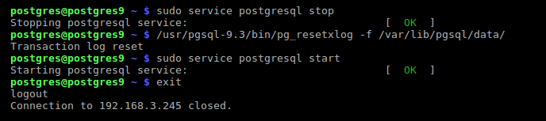
That’s all for master! Let’s proceed to the standby server’s configuration.

Configuring Standby PostgreSQL
- Access the environment with standby DB server via SSH in the same way you did it for the master one:
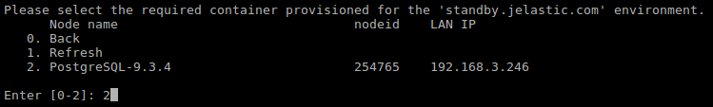
- Just after you’ve entered the DB container you need to stop it:
sudo service postgresql stop
- Then remove the old database with the following command:
rm -rf /var/lib/pgsql/data/*
- Copy a new database from the master server:
pg_basebackup -U webadmin -R -D /var/lib/pgsql/data/ --host={master_IP_address} --port=5432
Note: you should substitute the {master_IP_address} value with the IP address of your master PostgreSQL server.
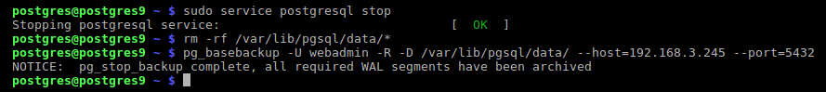
- To complete the configuration of standby DB switch back to the Jelastic dashboard and press the Config icon for PostgreSQL server in standby environment.
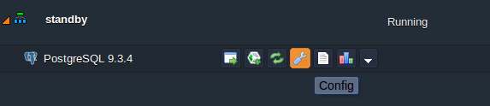
- In the opened Configuration manager locate the postgresql.conf file in the conf directory, uncomment the hot_standby = off parameter in the Standby Servers section, and change its value to on.
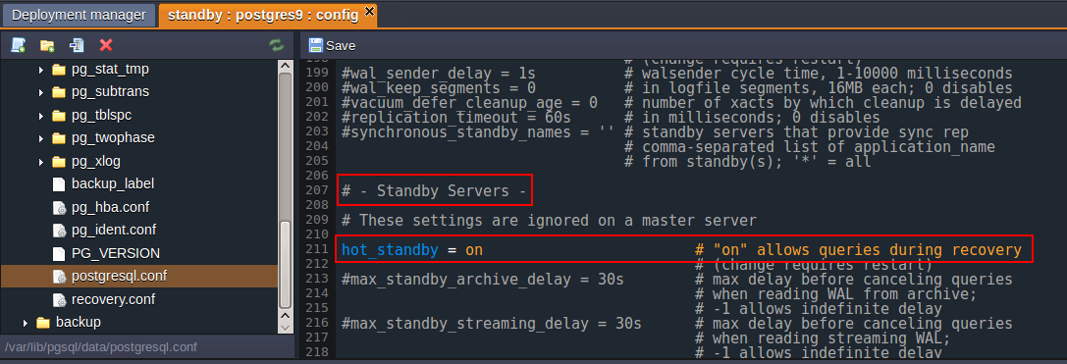
Save the changes you’ve performed.
- Finally, switch to your SSH console and run the container with slave DB:
sudo service postgresql start


Replication is configured! For now let’s check everything works fine.

Results Checking
- Open the phpPgAdmin panel for your master database by clicking Open in browser button next to it.
- Log in with the database credentials you've got via email earlier and create a new database.
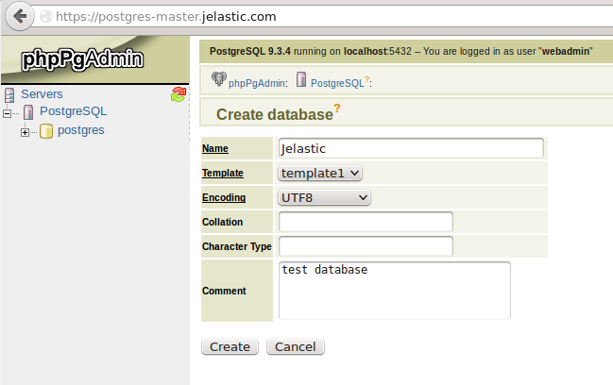
- Then you should open the admin panel of your standby database server (in the same way as for master one) and check if your new database was replicated successfully.
NOTE: as we’ve copied all the data and configurations from the master PG server to the standby PG server, credentials for admin access to the standby database became the same as to the master’s one.
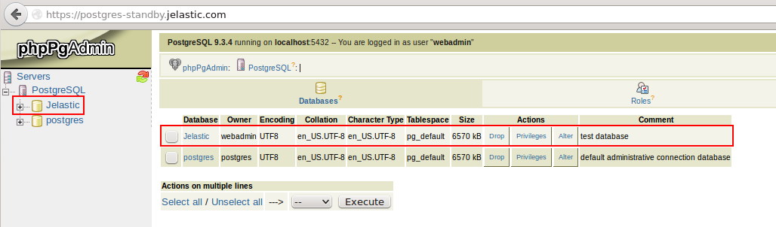
That's all. You've got a PostgreSQL highly-available database cluster. Enjoy!

How to Set Up PostgreSQL for High Availability and Replication with Hot Standby
Submitted by @jimtravis Feb 17, 2017
Learn how to configure PostgreSQL to run in Hot Standby mode on Google Compute Engine. You'll use two Compute Engine instances. One instance will run the primary PostgreSQL server and the other instance will run the standby server.
Alternatively, you can use Postgres as a service through Google Cloud SQL.
For most applications, data is a critical commodity. Storing data in one place is a risky proposition, so you need to have a strategy and a plan in place to ensure that you can recover from a failure as quickly as possible. One way to help prevent data loss is to store the same data on multiple servers and keep those databases synchronized.
PostgreSQL, or Postgres, offers various ways to archive and replicate the primary database for backup, high- availability, and load balancing scenarios. In Hot Standby mode, the system employs two or more servers:
- A primary server runs the active database. This database accepts connections from clients and permits read-write operations.
- One or more standby servers run a copy of the active database. These databases are configured to accept connections from clients and permit read-only operations. If the primary database server fails, the system can fail over to the standby server, which makes the standby server the active primary server.
The rest of this tutorial will use and discuss a single standby server.

Understanding Hot Standby
Here are some basic points you should understand about how Hot Standby works:
- Postgres uses write-ahead logging (WAL) to continuously archive database transactions. For each change made to the data files, WAL writes an entry in a log file. The system uses these log entries to perform point-in- time restoration from archives and to keep the standby server up to date. This means that when you set up Hot Standby, you're also setting up archiving.
- The process of updating the standby server with WAL entries is called streaming replication. This process operates asynchronously, which means it can take some time for the standby server to receive an update from the primary server. Though this delay can be very short, synchronization between the servers is not instantaneous. If your application requires strict consistency between the database instances, you should consider another approach.
- Postgres doesn't provide functionality to automatically fail over when the primary server fails. This is a manual operation unless you use a third-party solution to manage failover.
- Load balancing is not automatic with Hot Standby. If load balancing is a requirement for your appliction, you must provide a load-balancing solution that uses the primary server for read-write operations and the standby server for read-only operations.
Important: This tutorial covers a basic setup of two servers in a Hot Standby configuration. The tutorial doesn't try to cover every configuration that is available to you for this scenario. For a complete understanding of how to optimize Postgres in standby scenarios, refer to the Postgres documentation.

Objectives
- Set up two Compute Engine instances running Postgres.
- Create a new table for a guestbook app.
- Configure the primary server.
- Back up the primary server to the standby server.
- Configure the standby server to run in Hot Standby mode.
- Start the standby server and test it.

Before you begin
Select or create a Cloud Platform project.

Costs
This tutorial uses billable components of Cloud Platform, including:
- Google Compute Engine
Use the Pricing Calculator to generate a cost estimate based on your projected usage.

Setting up the Compute Engine instances
To create the primary and standby servers, follow the steps in How to Set Up PostgreSQL on Compute Engine. Note the following items:
- You won't need to use pgAdmin for this tutorial.
- Follow the installation steps twice, once for each server.
- Follow the steps in Connecting remotely.
- You'll need to open the network port only once, not once for each server.
- Note the IP address of each server. You'll need these values when you modify the configuration files.
- Keep an SSH window open for each server as you work through this tutorial.

Creating the guestbook table
On the primary server, create a simple table for testing purposes. This table stores entries for a website's guestbook, where visitors to the site can leave a comment. The data fields include the vistor's email address, a serial ID, the current date and time, and a text message written by the visitor.
In the SSH terminal for the primary server:
- Run the root shell:
$ sudo -s
- Run PSQL as user postgres and access the database named postgres:
$ sudo -u postgres psql postgres
- At the PSQL prompt, enter the following command to create the table:
CREATE TABLE guestbook (visitor_email text, vistor_id serial, date timestamp, message text);
- Add an entry to the table:
INSERT INTO guestbook (visitor_email, date, message) VALUES ( 'jim@gmail.com', current_date, 'This is a test.');
You should see a confirmation message that says: INSERT 0 1.
- Enter \q to exit PSQL.
Don't exit the root shell. You'll use the root shell throughout this tutorial.

Configuring the primary server
To configure the primary server, you will:
- Create a Postgres user for replication activities.
- Create a directory to store archive files.
- Edit two configuration files: pg_hba.conf and postgresql.conf.

Create a user for replication
To perform replication, Postgres requires a user, also called a role, with special permissions. On the primary server, run the following command:
$ sudo -u postgres createuser -U postgres repuser -P -c 5 --replication
This command performs the following actions:
- sudo -u postgres ensures that the createuser command runs as the user postgres. Otherwise, Postgres will try to run the command by using peer authentication, which means the command will run under your Ubuntu user account. This account probably doesn't have the right privileges to create the new user, which would cause an error.
- The -U option tells the createuser command to use the user postgres to create the new user.
- The name of the new user is repuser. You'll enter that username in the configuration files.
- -P prompts you for the new user's password. Important: For any system with an Internet connection, use a strong password to help keep the system secure.
- -c sets a limit for the number of connections for the new user. The value 5 is sufficient for replication purposes.
- --replication grants the REPLICATION privilege to the user named repuser.

Create the archive directory
Create a directory to store archive files. This directory is a subdirectory of the cluster's data directory, which is named main by default. You'll use this path in one of the configuration files. If you have configured your cluster to use a different directory for data, you must create your archive directory in that directory and then change the corresponding configuration setting.
In the SSH terminal for the primary server, enter the following command:
$ mkdir -p ../../var/lib/postgresql/main/mnt/server/archivedir

Edit pg_hba.conf
This configuration file contains the settings for client authentication. You must add an entry for the user repuser to enable replication.
- Edit the file. For PostgreSQL version 9.3, you can enter::
$ nano ../../etc/postgresql/9.3/main/pg_hba.conf
- After the example replication entries, add the following lines. Replace `` with the external IP address of the standby server:
# Allow replication connections
host replication repuser /32 md5
- Save and close the file.

Edit postgresql.conf
This configuration file contains the main settings for Postgres. Here, you will modify the file to enable archiving and replication.
Important: Don't forget to uncomment any lines you edit in the configuration files, or your changes won't take effect.
- Edit the file. In the terminal for the primary server, enter the following command:
$ nano ../../etc/postgresql/9.3/main/postgresql.conf
- In the WRITE AHEAD LOG section, in the Settings section, change the WAL level:
wal_level = hot_standby
- In the Archiving section, change the archive mode:
archive_mode = on
- Change the value for the archive command. This setting tells Postgres to write the archive files to the directory that you created in a previous step:
archive_command = 'test ! -f mnt/server/archivedir/%f && cp %p mnt/server/archivedir/%f'
- In the REPLICATION section, in the Sending Server(s) section, change the value for the maximum number of WAL sender processes:
max_wal_senders = 3
For this tutorial, the value of 3 is sufficient to enable backup and replication.
- Save and close the file.

Restart the primary server
Now that you've made the configuration changes, restart the server to make the changes effective. Enter the following command:
$ sudo service postgresql restart

Backing up the primary server to the standby server
Before making changes on the standby server, stop the service. In the SSH terminal for the standby server, run the following command:
$ sudo service postgresql stop
Important: Don't start the service again until all configuration and backup steps are complete. You must bring up the standby server in a state where it is ready to be a backup server. This means that all configuration settings must be in place and the databases must be already synchronized. Otherwise, streaming replication will fail to start.

Run the backup utility
The backup utility, named pg_basebackup, will copy files from the data directory on the primary server to the same directory on the standby server.
- Make sure you're running commands in the root shell. In the SSH terminal for the standby server, enter the following command:
$ sudo -s
Continue to use the root shell for the remainder of this tutorial.
- The backup utility won't overwrite existing files, so you must rename the data directory on the standby server. Run the following command:
$ mv ../../var/lib/postgresql/9.3/main ../../var/lib/postgresql/9.3/main_old
- Run the backup utility. Replace `` with the external IP address of the primary server.
$ sudo -u postgres pg_basebackup -h -D /var/lib/postgresql/9.3/main -U repuser -v -P --xlog-method=stream
The backup utility will prompt you for the password for the user named repuser.
The backup process should take just a few moments. When it's done, you can move on to configuring the standby server.

Configuring the standby server
To configure the standby server, you'll edit postgresql.conf and create a new configuration file named recovery.conf.

Edit postgresql.conf
For the standby server, you only need to change one setting in this file. Follow these steps:
- Edit the file. In the terminal for the standby server, enter the following command:
$ nano ../../etc/postgresql/9.3/main/postgresql.conf
- In the REPLICATION section, in the Standby Servers section, turn on Hot Standby and uncomment the line:
hot_standby = on
- Save and close the file.

Create the recovery configuration file
When you implement a server in Hot Standby mode, you must supply a configuration file that contains the settings that will be used in the event of data recovery. This file is named recovery.conf. To add this file to the standby server, follow these steps:
- Copy the sample recovery file to the proper location. In the terminal for the standby server, enter the following command:
$ cp -avr ../../usr/share/postgresql/9.3/recovery.conf.sample /../../var/lib/postgresql/9.3/main/recovery.conf
- Edit the recovery file:
$ nano /../../var/lib/postgresql/9.3/main/recovery.conf
- In the STANDBY SERVER PARAMETERS section, change the standby mode:
standby_mode = on
- Set the connection string to the primary server. Replace with the external IP address of the primary server. Replace with the password for the user named repuser.
primary_conninfo = 'host= port=5432 user=repuser password='
- (Optional) Set the trigger file location:
trigger_file = '/tmp/postgresql.trigger.5432'
The trigger_file path that you specify is the location where you can add a file when you want the system to fail over to the standby server. The presence of the file "triggers" the failover. Alternatively, you can use the pg_ctl promote command to trigger failover.
- Save and close the file.

Start the standby server
You now have everything in place and are ready to bring up the standby server. In the terminal for the standby server, enter the following command:
$ service postgresql start

Seeing the replication at work
To demonstrate that the replication between the primary and standby servers is working, you can add a row to the guestbook table on the primary server and then query the standby server to see the new row.
Recall that you have already added one row to the table on the primary server. Start by verifying that the standby server has the same information.
- On the standby server, start PSQL:
$ sudo -u postgres psql postgres
- At the PSQL prompt, enter the following query:
select * from guestbook;
You should see that the table contains the single row that you originally added. Now, add a second row on the primary server.
- On the primary server, start PSQL:
$ sudo -u postgres psql postgres
- At the PSQL prompt, enter the following command:
INSERT INTO guestbook (visitor_email, date, message) VALUES ('jim@gmail.com', current_date, 'Now we are replicating.');
- Switch back to the standby server terminal and repeat the query for all rows of the guestbook:
select * from guestbook;
You should now see that the standby server has received the update from the primary server.
- To exit PSQL, enter \q.
- To exit the root shells, enter exit in each terminal window.

Troubleshooting
After completing all the steps, if you're not seeing the data replicate, you might have missed a step or some small detail. Common mistakes include:
- Leaving a setting commented out.
- Forgetting to replace placeholder text in a setting or command. For example, some settings require a host IP address or a password.
- Entering the wrong IP address or password.
- Using a primary server setting for the standby server or vice-versa.
If you find yourself in this state, here are the steps to follow:
- Look at the Postgres log on each server. These logs can contain information that will help you troubleshoot the issue.
$ less ../../var/log/postgresql/postgresql-9.3-main.log
- Check the primary server settings. If there are mistakes, fix them and then restart the server.
- Shut down the standby server.
- Check the standby server settings and correct them if needed.
- On the standby server, rename the main folder to something new, such as main_old_2:
$ mv ../../var/lib/postgresql/9.3/main ../../var/lib/postgresql/9.3/main_old_2
- On the standby server, run pgbasebackup again to synchronize the data. Substitute `` with your primary server's external IP address:
$ sudo -u postgres pg_basebackup -h -D /var/lib/postgresql/9.3/main -U repuser -v -P --xlog-method=stream
- The main folder now needs a copy of recovery.conf. You can simply copy it from the folder that you renamed to main_old_2:
$ cp ../../var/lib/postgresql/9.3/main_old_2/recovery.conf ../../var/lib/postgresql/9.3/main/recovery.conf
- Start the standby server.
- Retest the replication functionality.

Cleaning up
After you've finished the tutorial, you can clean up the resources you created on Google Cloud Platform so you won't be billed for them in the future. The following sections describe how to delete or turn off these resources.

Deleting the project
The easiest way to eliminate billing is to delete the project you created for the tutorial. If you don't want to delete the project, delete the individual instances, as described in the next section.
Warning: Deleting a project has the following consequences:
- If you used an existing project, you'll also delete any other work you've done in the project.
- You can't reuse the project ID of a deleted project. If you created a custom project ID that you plan to use in the future, you should delete the resources inside the project instead. This ensures that URLs that use the project ID, such as an appspot.com URL, remain available.
If you are exploring multiple tutorials and quickstarts, reusing projects instead of deleting them prevents you from exceeding project quota limits.
To delete the project:
- In the Cloud Platform Console, go to the Projects page.
- In the project list, select the project you want to delete and click Delete project. After selecting the checkbox next to the project name, click Delete project.
- In the dialog, type the project ID, and then click Shut down to delete the project.

Deleting instances
To delete a Compute Engine instance:
- In the Cloud Platform Console, go to the VM Instances page.
- Click the checkbox next to your lamp-tutorial instance.
- Click the Delete button at the top of the page to delete the instance.

Deleting firewall rules
Deleting firewall rules for the default network
To delete a firewall rule:
- In the Cloud Platform Console, go to the Firewall Rules page.
- Click the checkbox next to the firewall rule you want to delete.
- Click the Delete button at the top of the page to delete the firewall rule.

Hot Standby e Streaming Replication
A partir da versão 9.0 do PostgreSQL, é possível combinar hot standby e envio de registros (streaming replication) para compor uma solução de replicação. Os benefícios dessa solução são aqueles citados no artigo anterior (disponibilidade, confiabilidade, desempenho e/ou balanceamento de carga). Neste caso, teremos o envio assíncrono das transações realizadas no servidor principal para o servidor secundário e, além disso, o servidor secundário só aceitará consultas somente leitura (consultas que não modificam dados, ou seja, não escrevem no log de transação tais como SELECT, COPY TO, BEGIN, END, ROLLBACK); comandos como INSERT, UPDATE, DELETE, CREATE, ALTER, DROP, nextval() não são permitidos. A figura abaixo ilustra esse cenário:

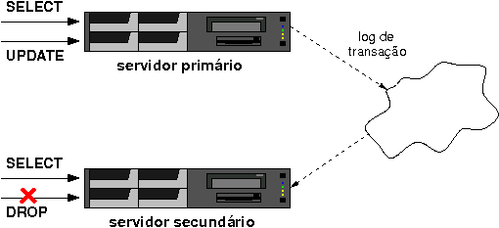
A implementação de tal cenário está descrita abaixo. Vale lembrar que os pré-requisitos apresentados no artigo anterior são utilizados aqui.
No servidor principal, editamos o arquivo /bd/primario/postgresql.conf:
listen_addresses = '*'
wal_level = hot_standby
max_wal_senders = 1
wal_keep_segments = 20
O parâmetro listen_addresses permite que o servidor secundário se conecte ao servidor principal para receber os logs de transação. O parâmetro wal_level indica o nível de log de transação armazenado no servidor principal; minimal (padrão) não permite que este tipo de replicação seja realizada. O parâmetro max_wal_senders indica o número máximo de servidores secundários permitidos. O parâmetro wal_keep_segments só é necessário se (i) for realizar a cópia dos arquivos com o servidor principal em atividade e (ii) se houverem paradas programadas do servidor secundário; este valor deve ser maior do que o número de arquivos de log de transação gerados durante a cópia dos arquivos. Neste caso, 20 é igual a 320 MB (20 * 16 MB).
A modificação desses parâmetros exige que o PostgreSQL do servidor principal seja reiniciado. Assim se a sua janela de manutenção não é flexível, programe-se. A aplicação dessas modificações não implica ter que iniciar a replicação imediatamente.
postgres@principal:~$ pg_ctl restart -D /bd/primario
waiting for server to shut down.... done
server stopped
server starting
No servidor principal, crie uma role (usuário) para replicar os dados. O PostgreSQL exige que o usuário que realiza a replicação seja um super-usuário e possa se conectar ao servidor primário.
postgres@principal:~$ psql
psql (9.0.1)
Type "help" for help.
postgres=# CREATE ROLE usuario SUPERUSER LOGIN;
CREATE ROLE
postgres=# \q
Dependendo da sua política de segurança, você pode precisar definir uma senha para este usuário. Neste caso, a senha deve ser informada no arquivo de senhas (~postgres/.pgpass ou %APPDATA%\postgresql\pgpass.conf no Windows) ou na string de conexão no arquivo /bd/secundario/recovery.conf.
postgres@principal:~$ psql
psql (9.0.1)
Type "help" for help.
postgres=# \password usuario
Enter new password:
Enter it again:
postgres=# \q
No servidor principal, edite o arquivo /bd/primario/pg_hba.conf. O método de autenticação vai depender da sua política de segurança. Se você decidiu colocar senha para o usuário que realiza a replicação, utilize o método de autenticação md5; caso contrário, utilize o método de autenticação trust.
host replication usuario 10.1.1.2/32 md5
A adição de uma nova regra de autenticação, exige a recarga das regras de autenticação.
postgres@principal:~$ pg_ctl reload -D /bd/primario
server signaled
No servidor secundário, edite o arquivo /bd/secundario/postgresql.conf:
hot_standby = on
O parâmetro hot_standby indica se o servidor secundário aceita conexões.
No servidor secundário, crie o arquivo /bd/secundario/recovery.conf. Este arquivo conterá informações sobre a aplicação das modificações realizadas no servidor principal e transmitidas para o servidor secundário.
standby_mode = 'on'
primary_conninfo = 'host=10.1.1.1 port=5432 user=usuario password=minhasenha'
trigger_file = '/bd/secundario/failover.trg'
O parâmetro standby_mode especifica se o servidor PostgreSQL é um servidor secundário (standby). O parâmetro primary_conninfo especifica como se conectar ao servidor principal. A senha (especificado em password) pode ser omitida ali e especificada no arquivo de senhas (~postgres/.pgpass ou %APPDATA%\postgresql\pgpass.conf no Windows). Se o parâmetro trigger_file for utilizado, indica que a presença do arquivo citado (/bd/secundario/failover.trg), termina a recuperação, ou seja, o servidor passa a ser um servidor principal (que aceita quaisquer tipos de comandos; não somente aqueles comandos somente leitura).
No servidor principal, teremos que realizar a cópia física dos arquivos para o servidor secundário. Há duas maneiras de realizar esta cópia dependendo da disponibilidade do servidor principal:
- com o servidor principal parado;
- com o servidor principal em atividade.
Se o servidor principal puder ficar parado durante a cópia, podemos fazer:
postgres@principal:~$ pg_ctl stop -D /bd/primario
waiting for server to shut down.... done
server stopped
postgres@principal:~$ rsync -av --exclude postgresql.conf \
--exclude pg_hba.conf --exclude pg_xlog/* --exclude pg_log/* \
/bd/primario/ postgres@10.1.1.2:/bd/secundario
postgres@principal:~$ pg_ctl start -D /bd/primario
server starting
Caso o servidor principal não possa parar, podemos fazer todo processo online. Neste caso precisamos executar os seguintes comandos no servidor principal:
postgres@principal:~$ psql
psql (9.0.1)
Type "help" for help.
postgres=# select pg_start_backup('replicacao', true);
pg_start_backup
-----------------
0/5044CB4
(1 row)

postgres=# \q
postgres@principal:~$ rsync -av --exclude postmaster.pid \
--exclude postgresql.conf --exclude pg_hba.conf \
--exclude backup_label --exclude pg_xlog/* --exclude pg_log/* \
/bd/primario/ postgres@10.1.1.2:/bd/secundario
postgres@principal:~$ psql
psql (9.0.1)
Type "help" for help.
postgres=# select pg_stop_backup();
NOTICE: WAL archiving is not enabled; you must ensure that all required
WAL segments are copied through other means to complete the backup
pg_stop_backup
----------------
0/90D7950
(1 row)

postgres=# \q
A primeira consulta (select pg_start_backup()) prepara o servidor para iniciar a cópia dos arquivos. O próximo passo é copiar os arquivos (utilizamos o rsync mas pode ser qualquer outro aplicativo) e, neste caso, temos que excluir alguns arquivos (postmaster.pid, postgresql.conf, pg_hba.conf, backup_label, pg_xlog/* e pg_log/*). Indicamos que a cópia já foi concluída executando a função (pg_stop_backup()). Vale lembrar que o parâmetro wal_keep_segments no servidor principal deve ser maior do que o número de arquivos de log de transação gerados durante a cópia. Isto porque o servidor secundário precisará destes arquivos (eles não podem ser reciclados) para "acompanhar" o servidor principal. Caso o parâmetro wal_keep_segments não seja suficiente, (i) você terá que aumentar o valor e realizar todo este passo novamente ou (ii) caso você esteja arquivando os arquivos de log de transação basta copiá-los para o diretório pg_xlog do servidor secundário.
Neste momento você pode iniciar o servidor secundário. Não se esqueça de criar os arquivos postgresql.conf e pg_hba.conf no servidor secundário.
postgres@secundario:~$ pg_ctl start -D /bd/secundario
server starting
Caso os logs estejam habilitados (logging_collector = on) no servidor secundário, as seguintes mensagens indicam que a replicação está acontecendo com sucesso:
LOG: database system was interrupted; last known up at 2010-11-14 14:08:19 BRT
LOG: entering standby mode
LOG: redo starts at 0/5044CB4
LOG: restartpoint starting: xlog
LOG: consistent recovery state reached at 0/A000000
LOG: database system is ready to accept read only connections
LOG: streaming replication successfully connected to primary
Neste momento, espera-se que o servidor secundário esteja "acompanhando" o servidor principal mas sempre em um estado consistente. Assim, a mesma consulta em ambos servidores podem retornar resultados diferentes (lembre-se que a replicação é assíncrona).
Se você tiver perguntas, as listas de discussão pgbr-geral (português) e pgsql-general (inglês) são bons lugares para perguntar.
Posted by Euler Taveira at

